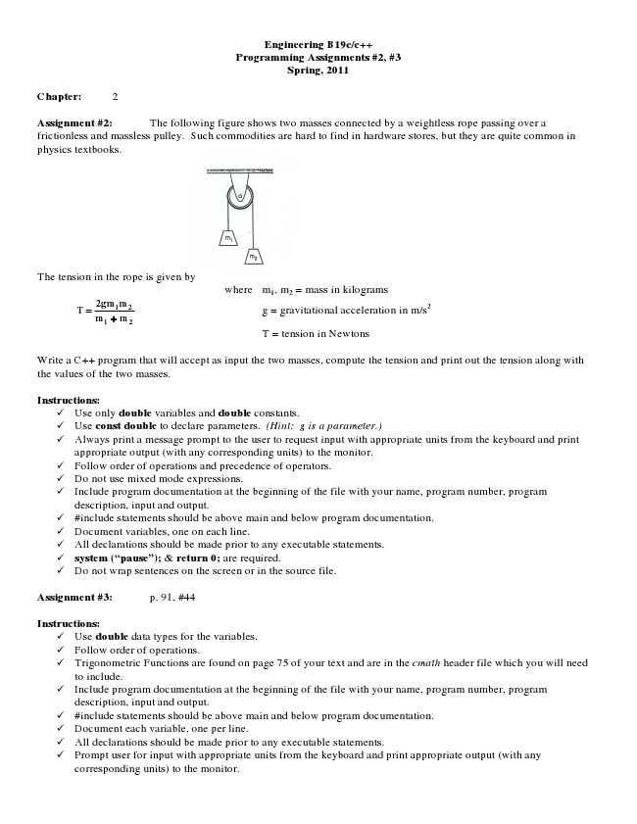

**Engineering B19c/c++ Programming Assignments #2, #3 Spring, 2011**

**Chapter: 2**

Assignment #2: The following figure shows two masses connected by a weightless rope passing over a frictionless and massless pulley. Such commodities are hard to find in hardware stores, but they are quite common in physics textbooks.

The tension in the rope is given by

where m

1

= mass in kilograms

**T**

**= mm mgm2**

**1**

+

**21**

2 g = gravitational acceleration in m/s2

T = tension in Newtons

Write a C++ program that will accept as input the two masses, compute the tension and print out the tension along with the values of the two masses.

**Instructions:**

✓ Use only double variables and double constants. ✓ Use const double to declare parameters. (Hint: g is a parameter.) ✓ Always print a message prompt to the user to request input with appropriate units from the keyboard and print

appropriate output (with any corresponding units) to the monitor. ✓ Follow order of operations and precedence of operators. ✓ Do not use mixed mode expressions. ✓ Include program documentation at the beginning of the file with your name, program number, program

description, input and output. ✓ #include statements should be above main and below program documentation. ✓ Document variables, one on each line. ✓ All declarations should be made prior to any executable statements. ✓ system (“pause”); & return 0; are required. ✓ Do not wrap sentences on the screen or in the source file.

**Assignment #3: p. 91, #44**

**Instructions:**

✓ Use double data types for the variables. ✓ Follow order of operations. ✓ Trigonometric Functions are found on page 75 of your text and are in the cmath header file which you will need

to include. ✓ Include program documentation at the beginning of the file with your name, program number, program

description, input and output. ✓ #include statements should be above main and below program documentation. ✓ Document each variable, one per line. ✓ All declarations should be made prior to any executable statements. ✓ Prompt user for input with appropriate units from the keyboard and print appropriate output (with any

corresponding units) to the monitor.

, m

2